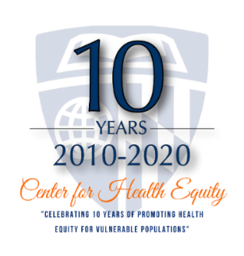
2020 AMFDP Annual Meeting Special Session via Zoom
Co-Sponsored by the Johns Hopkins Center for Health Equity

Leading Research Worthy of Community Trust
Thursday October 8th from 12:30 to 2:00 PM ET
The goals of the session are to
1) Describe lessons health equity researchers have learned regarding enhancing trustworthiness in community-engaged research
2) Discuss implications of these lessons for scholarship and leadership to advance health equity

Speakers
Lisa A. Cooper, MD, MPH, FACP 1995 AMFDP Scholar
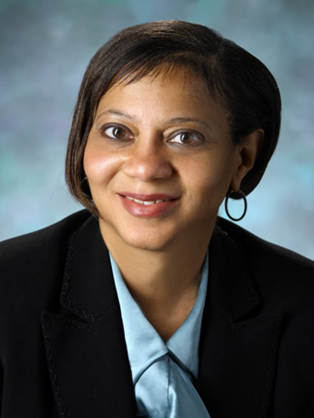
Dr. Lisa Cooper is the James F. Fries Professor of Medicine, and Bloomberg Distinguished Professor of Equity and Health and Health Care at Johns Hopkins University Schools of Medicine, Nursing, and Bloomberg School of Public Health. An international thought leader on health disparities, she studies how race and socioeconomic factors shape patient care, and how health systems, with communities, can improve the health of populations with complex social needs. A Liberian-born general internist and social epidemiologist, Dr. Cooper founded and directs the Johns Hopkins Center for Health Equity, where she and her team work, in partnership with health systems and community-based organizations, to identify interventions that alleviate racial and income health disparities and translate them into practice and policy changes that mean better health for communities. She has published over 200 articles and is the author of the forthcoming book, Why Are Health Disparities Everyone's Problem? (Johns Hopkins University Press, 2021). Dr. Cooper has been the principal investigator of numerous federal and private grants. She has mentored more than 60 scholars, 34 of whom are from underrepresented in medicine backgrounds. Dr. Cooper is a 2007 MacArthur Fellow and is an elected member of the National Academy of Medicine.

Deidra C. Crews, MD, ScM, FASN, FACP 2009 AMFDP Scholar
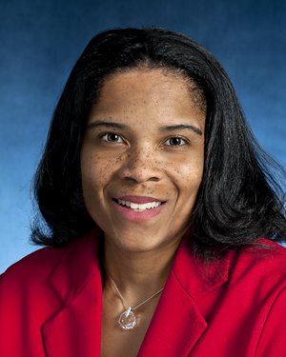
Dr. Deidra Crews is an Associate Professor of Medicine in the Division of Nephrology at the Johns Hopkins University School of Medicine. She holds appointments with the School of Nursing, the Welch Center for Prevention, Epidemiology and Clinical Research, the Center on Aging and Health, and the Center for Health Equity, where she is Associate Director for Research Development. Her research focuses on addressing disparities in the care and outcomes of kidney disease and hypertension. She received her undergraduate degree from the University of Virginia and her medical degree from Saint Louis University. Dr. Crews completed internal medicine residency, nephrology fellowship, and a master's in clinical epidemiology degree at Johns Hopkins. An elected member of the American Society for Clinical Investigation, Dr. Crews has received numerous awards for her research contributions, including the 2018 Johns Hopkins University President's Frontier Award—a $250,000 award granted to a single faculty scholar on the cusp of transforming their field. She was the inaugural Gilbert S. Omenn Fellow of the National Academy of Medicine. In 2019, Dr. Crews received the W. Lester Henry Award for Diversity and Access to Care from the American College of Physicians and the Distinguished Leader Award from the American Society of Nephrology.

Giselle Corbie-Smith, MD, MSc 1999 AMFDP Scholar
Dr. Giselle Corbie-Smith is a Kenan Distinguished Professor in the Departments of Social Medicine and Medicine at the UNC School of Medicine in Chapel Hill, NC. She is nationally recognized for her scholarly work on the inclusion of disparity populations in research, and has over a decade of experience in using community engagement to conduct innovative, translational health equity research. Dr. Corbie-Smith has served as the Principal Investigator of several community-based participatory research projects focused on disease risk reduction among rural racial and ethnic minorities. Her empirical work has focused on the methodological, ethical, and practical issues of research to address racial disparities in health. Dr. Corbie-Smith has transformed the way that academic investigators and community members interact while boosting public trust in research. In 2013, she established and became Director of the UNC Center for Health Equity Research where she and her team work to improve North Carolina communities’ health through shared commitment to innovation, collaboration, and health equity. Dr. Corbie-Smith is currently the Co-PI for the Robert Wood Johnson Foundation’s Advancing Change Leadership Clinical Scholars Program and recently served as the President of the Society of General Internal Medicine. In 2018, she was elected to the National Academy of Medicine.

Monica Peek, MD, MPH 2005 AMFDP Scholar
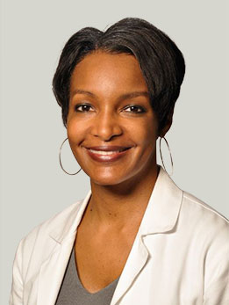
Dr. Monica Peek is an Associate Professor of Medicine and Associate Director of the Chicago Center for Diabetes Translational Research at the University of Chicago Medicine. She specializes in general internal medicine and preventive health for adults and studies how race and culture impact the patient/provider relationship, shared decision-making, and diabetes health outcomes. As principal investigator on two multi-year clinical studies, Dr. Peek aims to improve diabetes care and medical outcomes for patients on the South Side of Chicago. In her role as one of two inaugural Faculty Fellows in the Bucksbaum Institute for Clinical Excellence at the University of Chicago Medicine, she also explores how racial and cultural barriers impact physician-patient relations and shared decision-making. Dr. Peek has a particular interest in reducing health care disparities and concentrates these efforts on diabetes care and breast cancer-screening education for African American patients. Her clinical interests include preventive health care, chronic disease management, patient education, and women’s health. She serves on the boards of several advocacy organizations and is regularly involved in community-based education activities. Dr. Peek is the author of more than 60 peer-reviewed publications and abstracts exploring health care disparities in minority populations.

Carlos Jose Rodriguez, MD, MPH, FAHA, FACC 2006 AMFDP Scholar
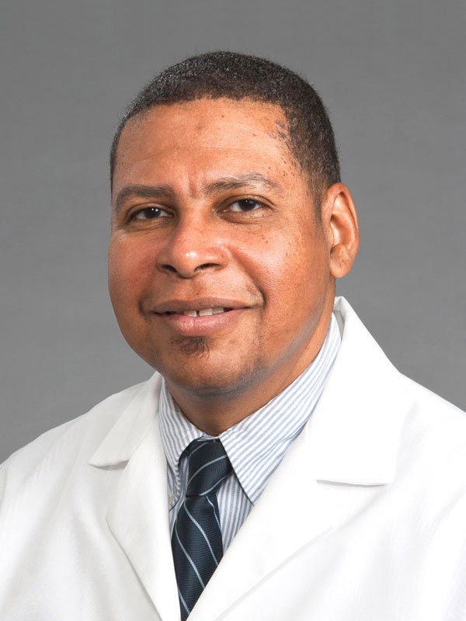
Dr. Rodriguez is a board-certified clinical cardiologist, Professor of Medicine and Epidemiology at Albert Einstein College of Medicine. He also serves as Vice Chair of Academic Affairs for Cardiology, Director of Cardiovascular Research, and Director of Cardiovascular Epidemiology at Albert Einstein College of Medicine. Dr. Rodriguez was the first Dominican from the surrounding inner-city community of Washington Heights to become a full-time faculty member of the Division of Cardiology. He is the principal investigator of two national multi-center studies of cardiac structure and function in Hispanic/Latinos across the United States. A prolific researcher, Dr. Rodriguez has published over 200 peer-reviewed manuscripts, book chapters, and abstracts. His research focuses on cardiovascular epidemiology, cardiovascular health disparities, minority cardiovascular health, hypertensive heart disease, and heart failure. Dr. Rodriguez has been the recipient of the American Heart Association Clinically Applied Research Grant, the Association of Black Cardiologists Hawthorne - Searle Young Investigator Award, and a Career Development Award funded by the National Heart Lung and Blood Institute. He is a Robert Wood Johnson Foundation Scholar, a past recipient of the Harold Amos Medical Faculty Development Award, and recipient of an Institutional Mid-Career Research Award.

